|  |  |
| --- | --- |
|  |  |
| |  | | --- | | **Features**   * **Main Page**   ◦ **Log in**  ◦ **Create new user**   * **Admin**   ◦ **Delete(close) any project**  ◦ **Modify any projects**  ◦ **Create a project**   * **Other users**   ◦ **Create their projects**  ◦ **Delete their own project**  ◦ **End a funded project**  ◦ **Fund a project** ◦ **SQL**   * + **Uid**   + **uname**   + **Upassword**   + **Upicurl (profile pic URL)**   + **Ucash** * **Project**   ◦ **SQL**   * + **Pid**   + **PTarget**   + **Pdeadline**   + **Pdesc**   + **Ppicurl** * **Donate**   ◦ **SQL**   * + **Uid**   + **Pid**   + **Dtime**   + **Damt**   + **Dtrans** | |
|  |

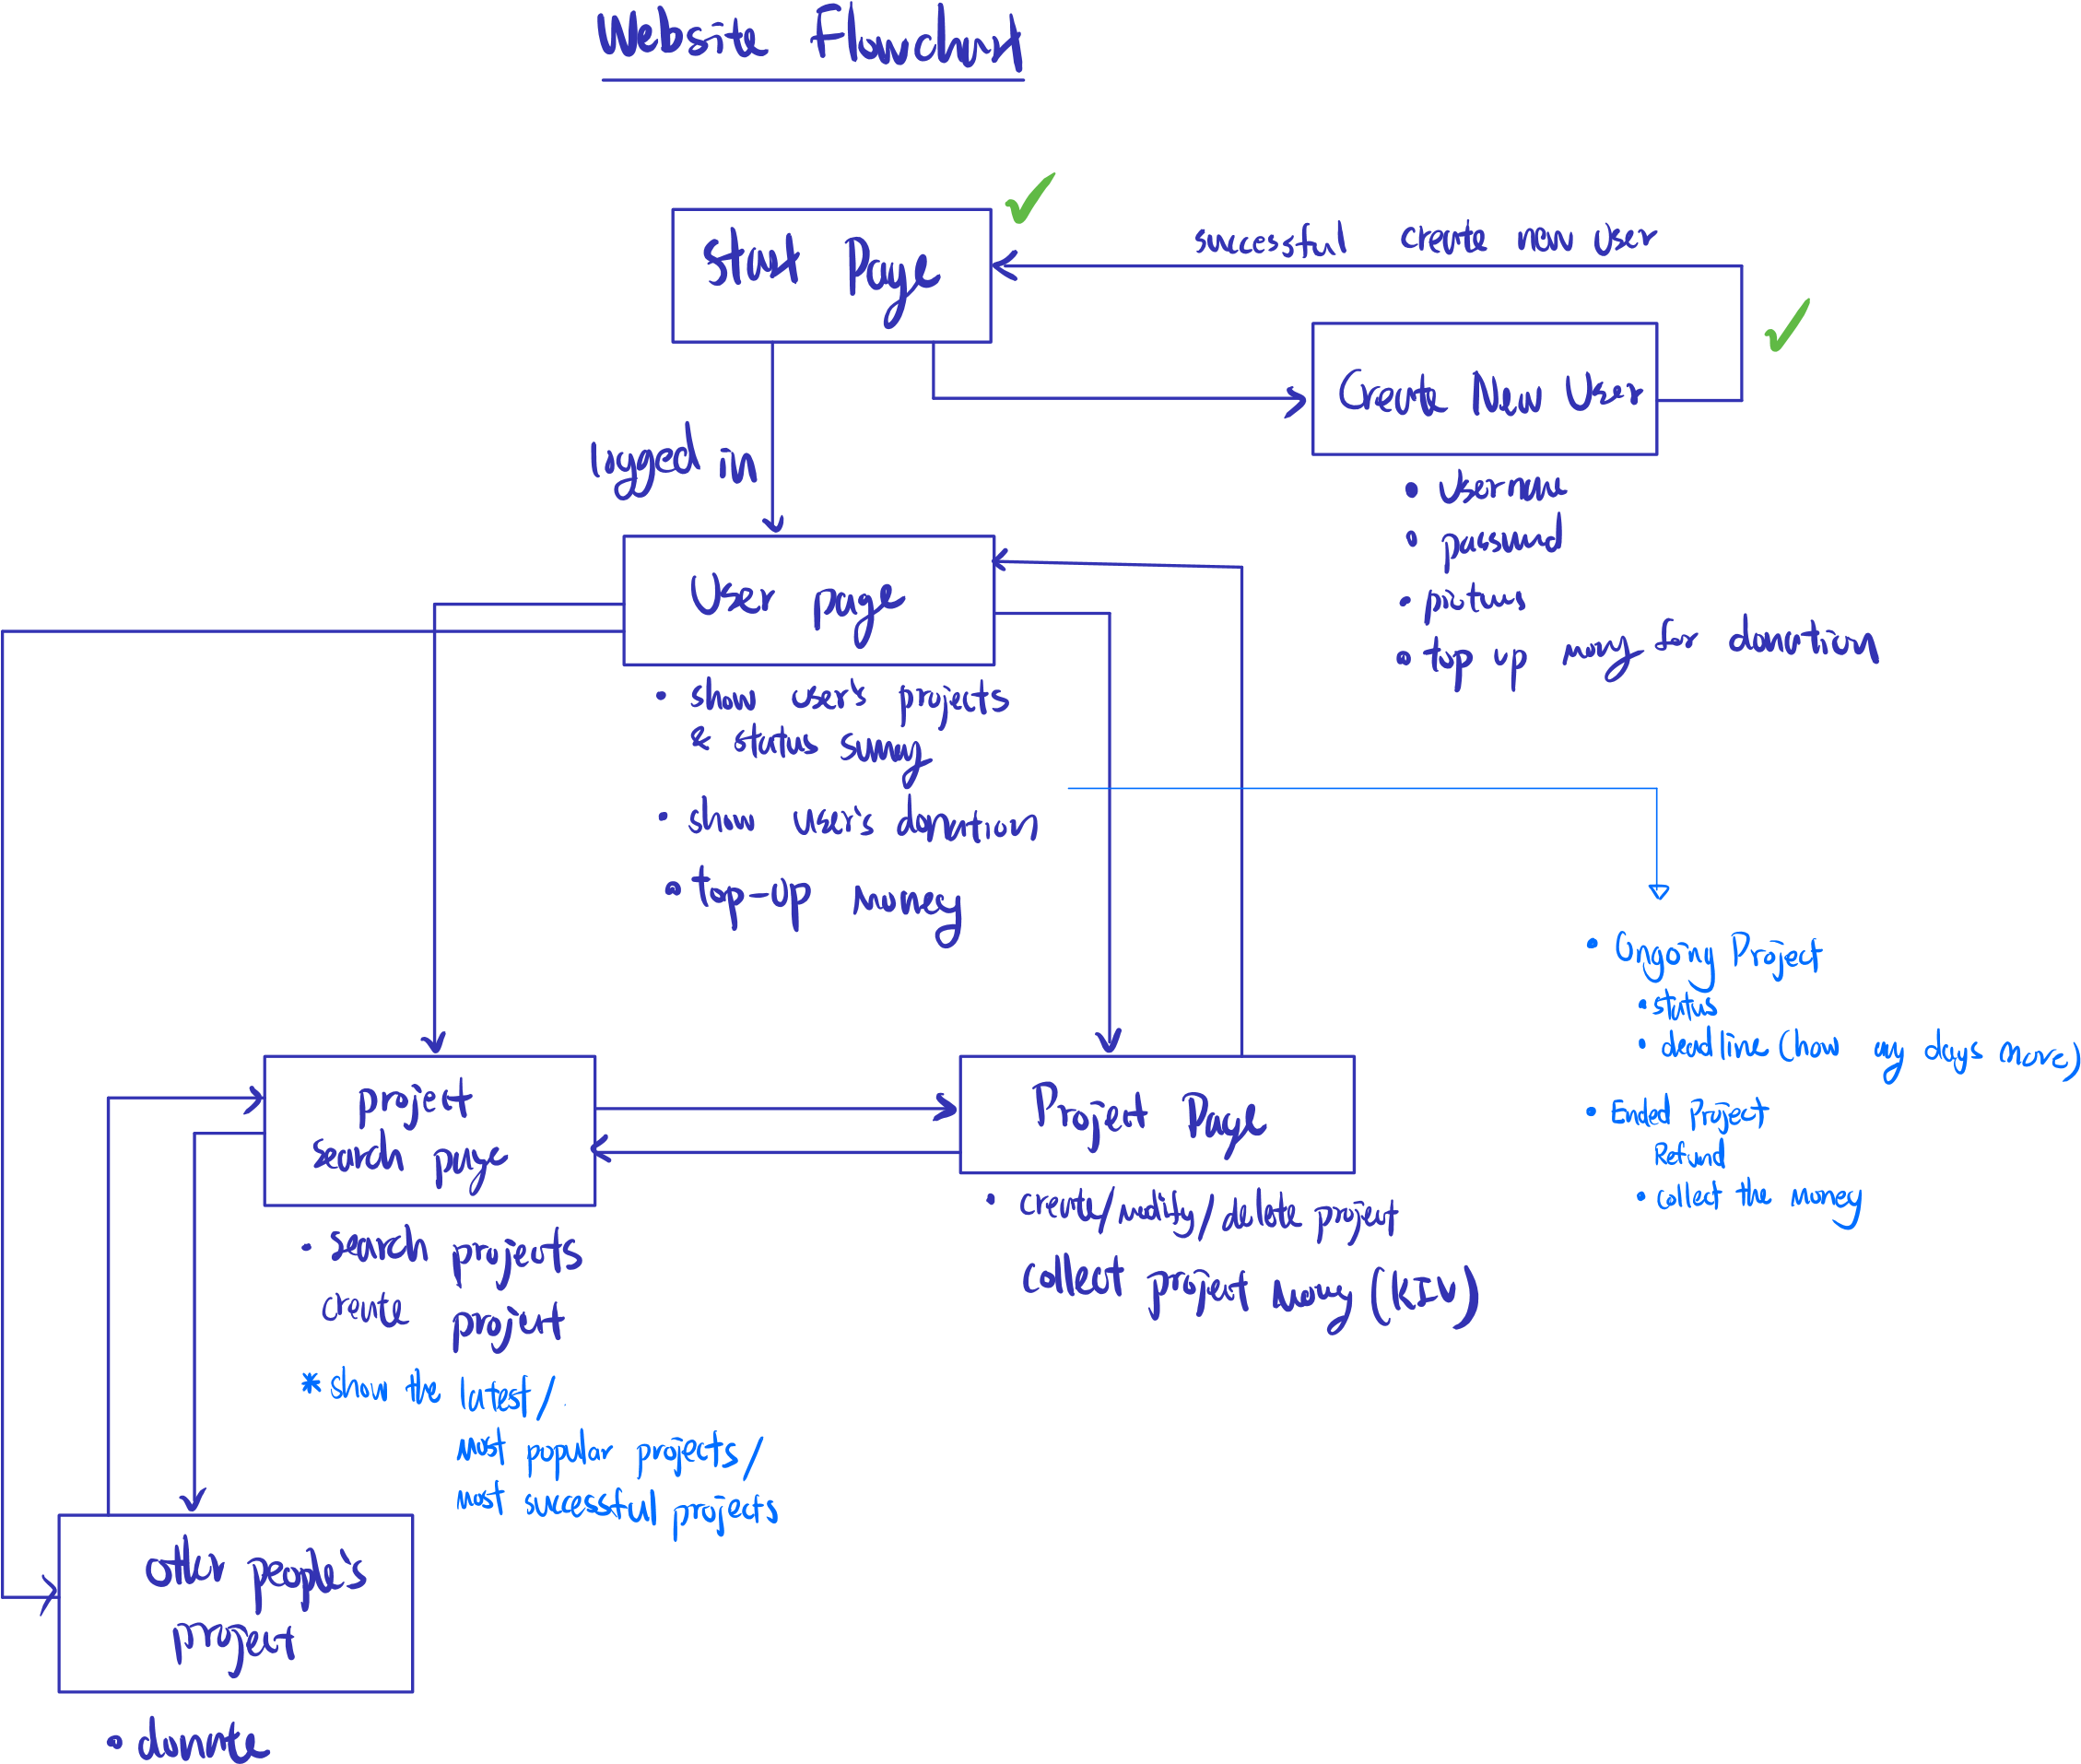

CREATE TABLE users(

uid VARCHAR(20) PRIMARY KEY,

uname VARCHAR(30) NOT NULL,

upassword VARCHAR(20) NOT NULL,

upicurl VARCHAR(100),

ucash NUMERIC CHECK(ucash >= 0)

);

CREATE TABLE projects(

pid VARCHAR(20) PRIMARY KEY,

uid VARCHAR(20),

ptarget NUMERIC NOT NULL CHECK(ptarget > 0),

pdeadline TIMESTAMP NOT NULL,

pdesc VARCHAR(500),

ppicurl VARCHAR(100),

FOREIGN KEY(uid) REFERENCES users(uid)

);

CREATE TABLE initiates(

uid VARCHAR(20),

pid VARCHAR(20),

CONSTRAINT i_keys PRIMARY KEY(

uid, pid

),

FOREIGN KEY(uid) REFERENCES users(uid),

FOREIGN KEY(pid) REFERENCES projects(pid)

);

CREATE TABLE donates(

uid VARCHAR(20),

pid VARCHAR(20),

dtime TIMESTAMP,

damt NUMERIC NOT NULL CHECK(damt > 0),

dtrans VARCHAR(20) NOT NULL,

CONSTRAINT d_keys PRIMARY KEY(

uid, pid, dtime

),

FOREIGN KEY(uid) REFERENCES users(uid),

FOREIGN KEY(pid) REFERENCES projects(pid)

);

DROP TABLE donates;

DROP TABLE users;

DROP TABLE projects;

DROP TABLE initiates;